Panasonic BDT110
General
Unique ID : 26589471757535162352738603551427086363 (0x1400F22C28F35D6D45430A949267481B)
Complete name : M:\Movies\Ripped DVD Films\Blue Ray\Rating 12\Master and Commander-DTS SH 6Ch.mkv
Format : Matroska
Format version : Version 2
File size : 32.0 GiB
Duration : 2 h 18 min
Overall bit rate mode : Variable
Overall bit rate : 33.2 Mb/s
Movie name : Master and Commander
Encoded date : UTC 2019-11-01 12:05:28
Writing application : MakeMKV v1.14.5 win(x64-release)
Writing library : libmakemkv v1.14.5 (1.3.5/1.4.7) win(x64-release)

Video
ID : 1
ID in the original source medium : 4113 (0x1011)
Format : AVC
Format/Info : Advanced Video Codec
Format profile : High@L4.1
Format settings : CABAC / 3 Ref Frames
Format settings, CABAC : Yes
Format settings, Reference frames : 3 frames
Codec ID : V_MPEG4/ISO/AVC
Duration : 2 h 18 min
Bit rate : 27.5 Mb/s
Width : 1 920 pixels
Height : 1 080 pixels
Display aspect ratio : 16:9
Frame rate mode : Constant
Frame rate : 23.976 (24000/1001) FPS
Color space : YUV
Chroma subsampling : 4:2:0
Bit depth : 8 bits
Scan type : Progressive
Bits/(Pixel*Frame) : 0.553
Stream size : 26.6 GiB (83%)
Language : English
Default : No
Forced : No
Original source medium : Blu-ray

Audio #1
ID : 2
ID in the original source medium : 4352 (0x1100)
Format : DTS XLL
Format/Info : Digital Theater Systems
Commercial name : DTS-HD Master Audio
Codec ID : A_DTS
Duration : 2 h 18 min
Bit rate mode : Variable
Bit rate : 4 123 kb/s
Channel(s) : 6 channels
Channel layout : C L R Ls Rs LFE
Sampling rate : 48.0 kHz
Frame rate : 93.750 FPS (512 SPF)
Bit depth : 24 bits
Compression mode : Lossless
Stream size : 3.98 GiB (12%)
Title : Surround 5.1
Language : English
Default : Yes
Forced : No
Original source medium : Blu-ray

Audio #2
ID : 3
ID in the original source medium : 4352 (0x1100)
Format : DTS
Format/Info : Digital Theater Systems
Codec ID : A_DTS
Duration : 2 h 18 min
Bit rate mode : Constant
Bit rate : 1 509 kb/s
Channel(s) : 6 channels
Channel layout : C L R Ls Rs LFE
Sampling rate : 48.0 kHz
Frame rate : 93.750 FPS (512 SPF)
Bit depth : 24 bits
Compression mode : Lossy
Stream size : 1.46 GiB (5%)
Title : Surround 5.1
Language : English
Default : No
Forced : No
Original source medium : Blu-ray
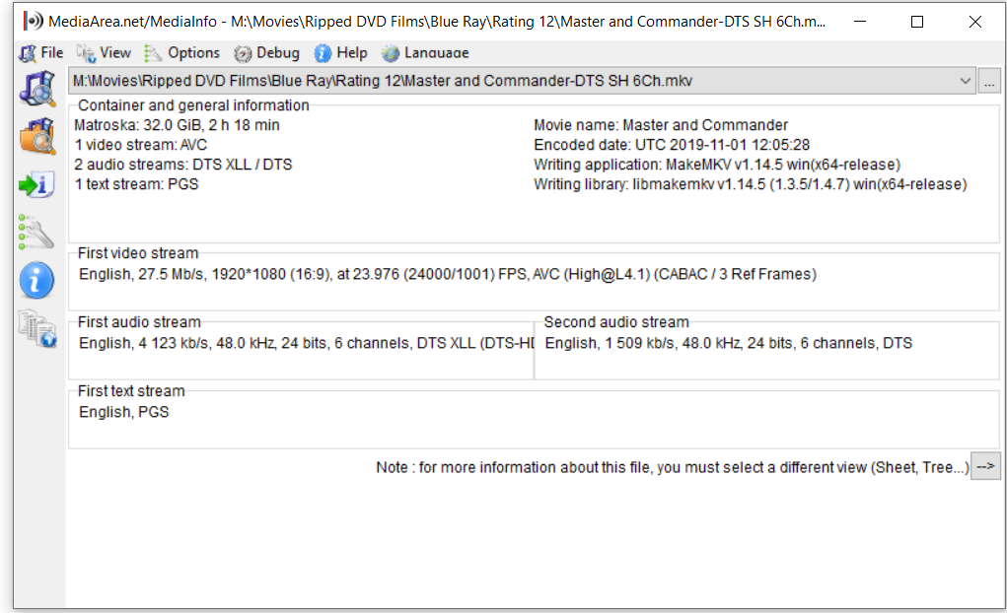

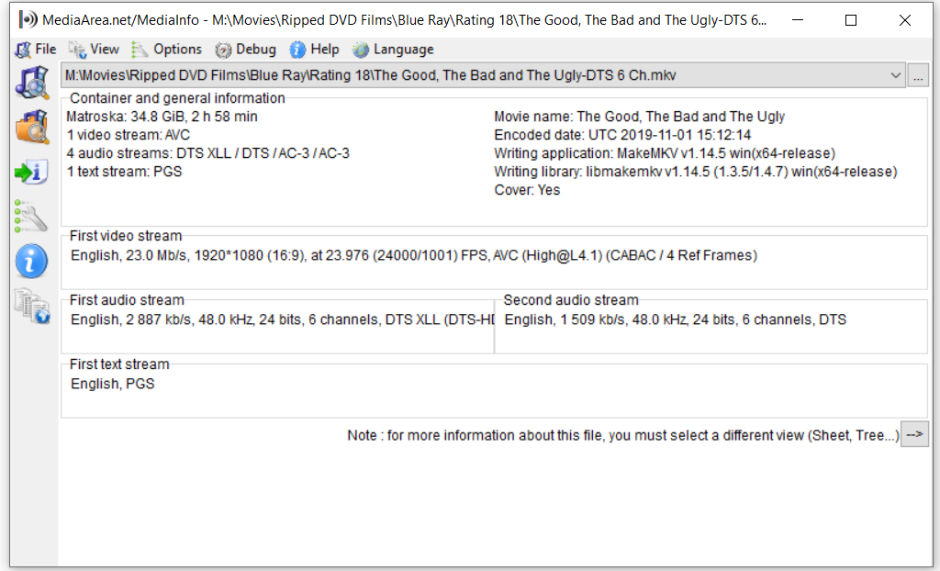

General
Unique ID : 89526952211027767438809353048970927548 (0x435A4389018395838E050B02EF429DBC)
Complete name : M:\Movies\Ripped DVD Films\DVD Ratings Group\Rating 15\Legends of The Fall (Superbit)-DTS 6Ch.mkv
Format : Matroska
Format version : Version 2
File size : 6.55 GiB
Duration : 2 h 7 min
Overall bit rate mode : Variable
Overall bit rate : 7 360 kb/s
Movie name : Legends of The Fall (Superbit)
Encoded date : UTC 2019-11-01 19:39:18
Writing application : MakeMKV v1.14.5 win(x64-release)
Writing library : libmakemkv v1.14.5 (1.3.5/1.4.7) win(x64-release)

Video
ID : 1
ID in the original source medium : 224 (0xE0)
Format : MPEG Video
Format version : Version 2
Format profile : Main@Main
Format settings : CustomMatrix / BVOP
Format settings, BVOP : Yes
Format settings, Matrix : Custom
Format settings, GOP : M=3, N=12
Format settings, picture structure : Frame
Codec ID : V_MPEG2
Codec ID/Info : MPEG 1 or 2 Video
Duration : 2 h 7 min
Bit rate mode : Variable
Bit rate : 6 600 kb/s
Maximum bit rate : 9 800 kb/s
Width : 720 pixels
Height : 576 pixels
Display aspect ratio : 16:9
Frame rate mode : Constant
Frame rate : 25.000 FPS
Standard : PAL
Color space : YUV
Chroma subsampling : 4:2:0
Bit depth : 8 bits
Scan type : Interlaced
Scan order : Top Field First
Compression mode : Lossy
Bits/(Pixel*Frame) : 0.637
Stream size : 5.87 GiB (90%)
Language : English
Default : No
Forced : No
Original source medium : DVD-Video

Audio
ID : 2
ID in the original source medium : 189 (0xBD)137 (0x89)
Format : DTS
Format/Info : Digital Theater Systems
Codec ID : A_DTS
Duration : 2 h 7 min
Bit rate mode : Constant
Bit rate : 755 kb/s
Channel(s) : 6 channels
Channel layout : C L R Ls Rs LFE
Sampling rate : 48.0 kHz
Frame rate : 93.750 FPS (512 SPF)
Bit depth : 16 bits
Compression mode : Lossy
Stream size : 687 MiB (10%)
Title : Surround 5.1
Language : English
Default : Yes
Forced : No
Original source medium : DVD-Video

Menu
00:00:00.000 : en:Chapter 01
00:02:03.480 : en:Chapter 02
00:07:42.680 : en:Chapter 03
00:12:38.040 : en:Chapter 04
00:14:24.680 : en:Chapter 05
00:20:57.320 : en:Chapter 06
00:24:24.360 : en:Chapter 07
00:32:42.880 : en:Chapter 08
00:38:14.600 : en:Chapter 09
00:43:12.800 : en:Chapter 10
00:48:01.080 : en:Chapter 11
00:50:25.960 : en:Chapter 12
00:54:28.840 : en:Chapter 13
00:57:04.920 : en:Chapter 14
01:03:16.760 : en:Chapter 15
01:04:49.720 : en:Chapter 16
01:06:20.640 : en:Chapter 17
01:09:07.560 : en:Chapter 18
01:14:23.080 : en:Chapter 19
01:18:43.280 : en:Chapter 20
01:26:46.680 : en:Chapter 21
01:28:38.840 : en:Chapter 22
01:33:21.000 : en:Chapter 23
01:34:23.080 : en:Chapter 24
01:37:49.360 : en:Chapter 25
01:42:56.800 : en:Chapter 26
01:49:09.560 : en:Chapter 27
01:55:33.000 : en:Chapter 28

On Serviio Server settings as follows:
- BDT 110 profile=BDT Panasonic Player (there are 5 other settings available)
- Transcoding set to=Enabled.
Before Transcoding was enabled, the DTS playback was on DD 2.0 channel. After enabled the playback is DD 5.1 channel.
IN ANY OF THESE SETTINGS, PLAYBACK CAN BE PAUSED BUT CANNOT RESUME AND SEARCH AND NEXT CHAPTER DOES NOT WORK.

